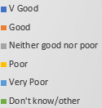
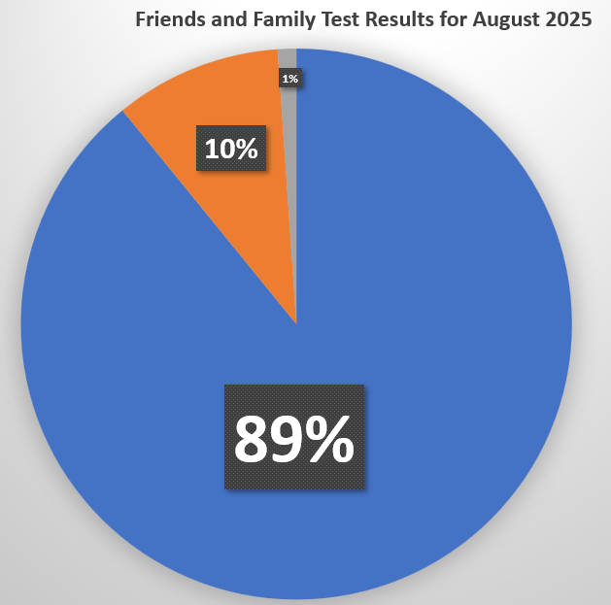
89% of our patients found our service to be Very Good (82 responses)

10% of our patients found our service to be Good (9 responses)

1% of our patients found our service to be Neither Good nor Poor
(1 responses)

0% of our patients responded Poor, Very Poor or Don’t know/other

You can complete the Family and Friends Test by,
- Responding to the Working Feedback SMS service
- A paper copy found in reception.
- On our website

