Dear Patient

We are all excited to hear about the progress of the rolling out of the Covid vaccine and look forward to this improving the quality of life for all of us.

We know that you, like us, are struggling with the continued confines imposed upon us all due to the Covid-19 pandemic.

Everyone is trying to make the best of the situation and, as a practice, we are committed to caring for you in the best possible way whilst keeping both you and our team safe.

To keep you as informed as possible, we will update these messages frequently as we become aware of more information from NHS England:

- The vaccines are being rolled out in a very strict order

- Please do not contact the surgery nor the hospital to seek a vaccine

- We will contact you when the NHS has informed us that you are eligible

- We are still open if you have any medical concerns and will offer advice via the telephone whenever we can to prevent you leaving home unnecessarily

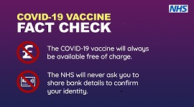

- With the current rapid increase in Covid-19 cases it is even more important to

wash your hands
wear a face mask as advised
keep 2 metres apart
Thank you for your patience
Dr Evan and Hockley Partners/Tina Till Practice Manager
20.01.21

