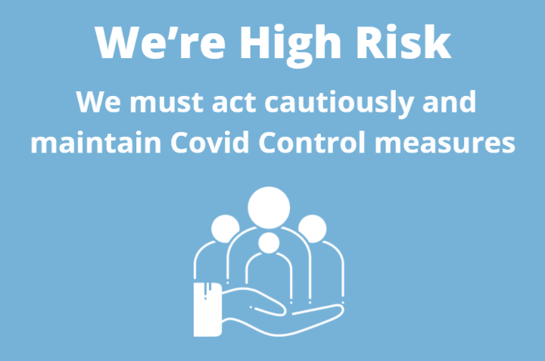

To all our Patients

We are aware of the planned move to lifting the remaining Covid restrictions in England from July 19th. However, please note:
NHS England has issued guidance making it clear that practices should continue with established infection control measures, including face coverings, from July 19th.
We are seeing the rates of Covid rise with the more transmissible Delta variant.
We are also experiencing major staff shortages due to staff having to isolate.
Please do not request your second Covid vaccine earlier than we are allowed to give this to you. Medical Advice is still to wait 8 weeks between your vaccines to give you the best possible protection against suffering from Covid
It is our duty to do all we can to keep both our patients and our staff safe whilst we deliver care.
We request understanding whilst we work through this new stage of the Covid Pandemic

Thank you
Dr Evans and Hockley

